Whitney Mountain Chapel

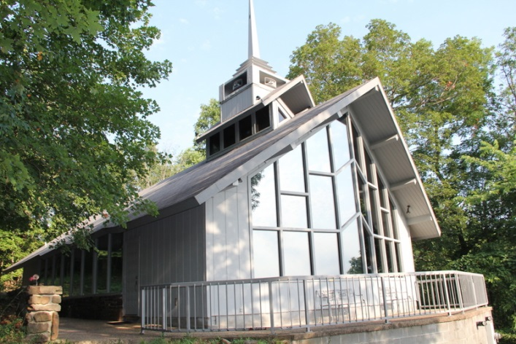

Pricing and Reservations!
RATES:
Our rates for enjoying beautiful Whitney Mountain Chapel are:
Wedding: $350 /2 hours
Rehearsal: $100 /1 hour
Extra time: $100 /1 hour
Deposit (required and non-refundable): $100
If any other questions arise, please call our wedding coordinator:
Noel Sloane,
Coordinator
(479) 359-2469

CONGRATULATIONS:
Whitney Mountain Chapel congratulates you on your upcoming marriage. We rejoice with you and offer our prayers and best wishes as you prepare to celebrate this important occasion.
We are pleased that you are considering our chapel for your wedding ceremony. When the time has come to tie the knot, WMC is the preferred venue to celebrate a couple’s commitment to each other in the presence of all of their friends and family. Whether your guests are coming into town for the day, or traveling to your wedding destination to enjoy a few days of extended celebrations, welcoming your wedding guests at WMC is a beautiful way of showing your appreciation of beauty and thoughtfulness.
For our part we'll do our best to ensure that you leave us with great memories of a beautiful experience. In order to achieve that success, please observe a few of our expectations noted in this letter. We hope it will be a valuable resource as you make your wedding plans.

USE:
We find that most ceremonies can be completed within 2 hours, including pictures. Typically, rehearsal is additionally allotted 1 hour. If more time is needed, please arrange this when booking, as others may want to use the Chapel as well. Although we want you to savor every moment, promptness in arriving for the rehearsal and the wedding itself is important, especially for the minister.
We are sure that your choice of Minister and music would be best to suit your needs. Happily, WMC has a beautiful organ and an electric piano that is at your disposal.
The chapel will seat 120 people comfortably, and there are men’s and ladies facilities in the narthex. For insurance reasons, we must be sure that guests are not permitted in the loft area.
As many weddings use candles as part of the ceremony, we must insist that they be dripless and protected. Please use the candle-snuffer to extinguish all candles when the wedding is over. Decorating the pews is usually done with bow clips to secure flowers and bows. We have found it environmentally sound to discourage the throwing of rice anywhere on WMC property. A lovely substitute has been the use of bubbles.
FINAL:
It is expected that the Chapel will be left in in good order, in anticipation of other scheduled weddings like yours. There can be no smoking, food, or alcoholic beverages allowed in the Chapel. We must insist that you are ultimately responsible for any damages.

